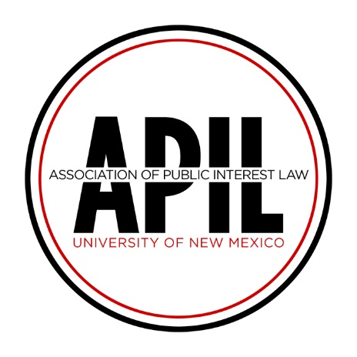

University of New Mexico School of Law
1117 Stanford Dr NE
MSC11 6070 1 University of New Mexico
Albuquerque, NM 87131-0001
apil.fellowships@gmail.com

2022 APIL Summer Award Application

Dear Student,

Thank you for your interest in the Association of Public Interest Law (APIL) Summer Award. Submitting the following application will make you a candidate for The Craig Othmer Scholarship and/or any additional funding awards APIL provides for the 2022 Summer.

What is “public interest” law?

APIL believes that the parameters of “public interest law” are quite broad. We believe that many kinds of legal work might be in the “public interest,” and we encourage applicants to articulate in their application how their summer work will serve the social or economic needs of their community (on a small or large scale). For example, past award recipients have worked for non-profits, public criminal law work, and advocacy or pro bono organizations. Finally, while we do not have a specific type of job in mind (so long as it falls under this broad “public interest” definition), APIL generally looks most favorably on work that has a concrete impact on our society’s most marginalized members—the exploited, the ignored, the poor, the powerless, and those who otherwise lack the means to defend themselves.

APPLICATION REQUIREMENTS

- Applicants must submit all required application materials (see below) to the APIL Award Committee email, apil.fellowships@gmail.com by 5:00pm on March 28, 2022.

☐ Completed and Signed Application Form (below);
☐ Statement of Interest;
☐ Current Resume; and
☐ Offer from Host Organization(s) if available at the time of submission. If not, proof of unpaid public interest position is required by April 11, 2022, in order for funds to disburse

- Applicant must work at least 200 hours in an unpaid public interest position over the
course of the summer.
3. Applicant must work under the supervision of an attorney licensed to practice law.

NOTE:

1. The APIL Fellowship Committee has sole discretion over any awards made.

2. Award selection and amounts will be determined by factors including, but not limited to:
- the number of applications received;
- the amount of money available from the award fund;
- applicants’ present, and future commitment to public interest work; and
- applicants’ position with a New Mexico organization or issues facing New Mexican residents.

Application Form

- Personal Information

Name:

Address:

Phone:

E-mail:

Class:

- Host Organization Information: Please provide a written offer from your host organization(s) verifying your employment with them for the summer of 2022, if available. If not available, please remember to submit proof of employment by April 11 or you will lose the funding to another applicant.

Organization:

Address:

Phone:

Supervising Attorney:

Supervising Attorney’s Phone:

- Additional Host Organization(s): If you have accepted multiple public interest positions, please provide host organization information regarding the additional position(s).

Organization:

Address:

Phone:

Supervising Attorney:

Supervising Attorney’s Phone:

If you will have more than one position over the summer, please describe your summer employment scheduling plans.

- How does your host organization serve the New Mexico community (if not in New Mexico, the community where it is located)?

- Financial Need: Please describe your financial need for a summer funding and include a description of any additional funding you will receive during the summer (student loans, other fellowships, scholarships, savings, family financial support, trust funds, etc.). In addition, please indicate any additional funding for which you have applied but have not yet received a response. Attach additional pages if needed.

- Statement of Interest: Please attach a statement of interest (one to two pages). In your statement, please address some (or all) of the following: (1) your life experience/background that draws you to your summer work, or other relevant personal information; (2) how you hope to contribute to the field of public interest law; (3) why you chose to work for this organization (or these organizations); (4) what you hope to learn and accomplish during your summer work there; and/or (5) your perspectives on the importance of public interest work in the legal field.

By signing or typing my name below, I attest that all the information submitted in this application is, to the best of my knowledge, true and accurate.

_______________________________________ _________________
Signature Date

Additional funding is contingent on receipt of funds by APIL prior to award date.

