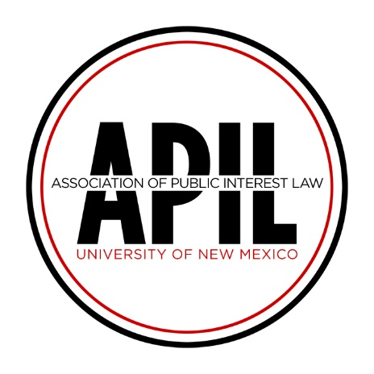

University of New Mexico School of Law
1117 Stanford Dr NE
MSC11 6070 1 University of New Mexico
Albuquerque, NM 87131-0001
SO-APILFellowships@law.unm.edu

2020 Summer Fellowship Application

Dear Student,

Thank you for your interest in the Association of Public Interest Law Summer Fellowship Program.

Application Requirements

1. Applicant must already have secured an unpaid public interest position prior to submitting her/his application.

2. Applicant must commit to working at least 200 hours over the course of the summer in her/his chosen unpaid position.

3. Applicant must work under the supervision of an attorney licensed to practice law.

4. Applicants must submit all required application materials to the APIL Fellowship Committee SO-APILFellowships@law.unm.edu by April 3, 2020.

5. Any student who receives a fellowship will be required, by the second week of the following Fall semester, to provide the APIL Board with a written report of her/his summer work experience. This report shall describe (1) the work performed and (2) the professional, educational, and personal value of the experience. *

6. Any student who receives a fellowship will also be required, by the second week of the following Fall semester, to provide the APIL Board with a brief report from her/his supervising attorney describing how the organization benefitted from the work of the fellowship recipient. *

* These reports shall be retained by the APIL Secretary, may be made available for public view, and may be used to generate promotional materials for APIL. If you are awarded funding and do not complete your summer fellowship, you will be required to refund your fellowship money to APIL no later than the second Friday of the following Fall semester. Failure to comply with all application provisions or dishonesty in the application process may constitute a violation of the Student Code of Conduct and may subject you to disciplinary action.

2020 APIL Summer Fellowship

APPLICATION

To be considered for a 2020 APIL Summer Fellowship, please submit the required documents to the APIL Fellowship Committee at SO-APILFellowships@law.unm.edu no later than 5:00pm on Friday, April 3, 2020. Late applications will not be considered.

For you to be considered for funding, your summer position (1) must be in an area of public interest, (2) must be unpaid, and (3) must be for at least 200 hours over the course of the summer.

NOTE:

1. The APIL Fellowship Committee has sole discretion over any fellowship awards made.

2. Fellowship selection and award amounts will be determined by factors including, but not limited to:
  - the number of applications received;
  - the amount of money available from the fellowship fund;
  - applicants’ past, present, and future commitment to public interest work;
  - applicants’ position with a New Mexico organization or issues facing New Mexican residents;
  - applicants’ year in Law School (preference given to 1L and 2L students).

Required Application Materials:

Email the following materials as attachments to the Fellowship Committee at
SO-APILFellowships@law.unm.edu no later than 5:00pm on April 3, 2020:

☐ Completed and Signed Application Form (below);
☐ Current Resume; and
☐ Written Offer from Host Organization(s).
(Note: If you have secured a position but have not yet received a written offer, please inform the Fellowship Committee. If you are awarded a fellowship, you will be required to provide the Committee with a copy of your written offer(s) within one week of having been awarded the fellowship.)

APPLICATION FORM

- Personal Information

Name:

Address:

Phone:

E-mail:

Class:

- Host Organization Information: Please provide a written offer from your host organization(s) verifying your employment with them for the summer of 2020.)

Organization:

Address:

Phone:

Supervising Attorney:

Supervising Attorney’s Phone:

- Additional Host Organization(s): If you have accepted multiple public interest positions, please provide host organization information regarding the additional position(s).

Organization:

Address:

Phone:

Supervising Attorney:

Supervising Attorney’s Phone:

3a. If you will have more than one position over the summer, please describe your summer employment scheduling plans.

- How does your host organization serve the New Mexico community (if not in New Mexico, the community where it is located)?

- Statement of Interest: In your statement of interest, please describe the following: (1) your past and current public interest involvement; (2) how you hope to contribute to the field of public interest law; (3) why you chose to work for this organization (or these organizations); and (4) what you hope to learn and accomplish during your summer work there. Attach additional pages if needed.

- Financial Need: Please describe your financial need for a fellowship and include a description of any additional funding you will receive during the summer (student loans, other fellowships, scholarships, savings, family financial support, etc.). In addition, please indicate any additional funding for which you have applied but have not yet received a response. Attach additional pages if needed.

- Please describe any involvement with APIL and/or your plans for future involvement with APIL.

By signing or typing my name below, I attest that all the information submitted in this application is, to the best of my knowledge, true and accurate.

__________________________________________________ ______________________________
Name – (Signed or Typed) Date

